Whats going on Currently:

* Experiment number 1: working on the pipeline to get querrying done on a sample document. Currently using a paul graham’s text passage to index it using LLamaIndex library and instructions. Current problems being -> not able to get the basic OpenAI key to work due to some quota limitations. Looking into downloading the weights of a LLAMA-2 model to use in place of the OpenAI key – looking into that.

Once the text becomes indexed, it can be querried in this format   
  
“ what did the author do growing up” -> Answered by the LLM

The example of Paul Grahams passage is taken so as to see the performance of the answer given by the llm model being used. In the example given below we can see performance by a GPT-4 model. Since such a resource is available to test against, having the question asked by the user, reference context from the passage being stated and the reference answer given by the llm also provided.   
  
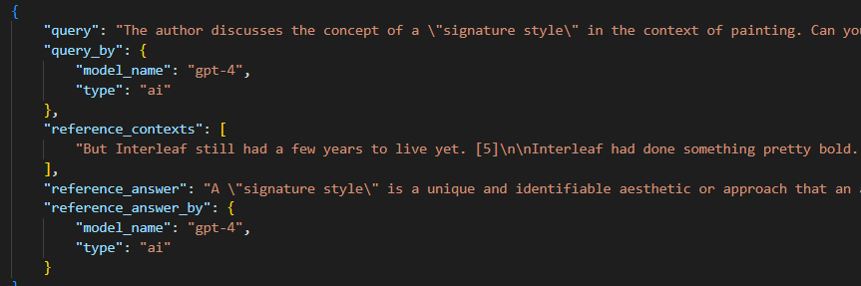

Once the queries are made using an opensource model such as Llama or Mistral, I would compare the performance of the response (Question : how can that be done). Once the metric is received we can look into working on our application.   
  
Now the questions I would want to ask :

Once the first experiment as described above is done, there are 2 applications we can build :

* **Lecture assistant** – given lecture slides and lecture transcripts -> querying on that
* College Handbook helper – Given the handbooks of different courses, helps answer student queries such as -> “what are the requirements required to be fulfilled to go on Erasmus as a mechanical engineering student” : answered as per the engineering handbook fed into the model.

Before our next meeting I plan on getting a better grasp over the indexer and querying environment. Along with that I can build a slice of the application that we decide on making.( A slice being just work with 1 or 2 examples rather than doing the whole thing at once -> seeing how our example is suitable with the current setup)

This brings us to the final question which is that what should we be doing in this thesis that would make it worthy of a publication?

* Currently not doing any thing
* Hence, what aspects can be looked into to get a publishing level thesis at this point ?